

Question:

Online Course Learning Management System: Develop an e-learning platform where instructors can upload courses and learning materials while students can enroll, attend assessments, track progress, and receive certificates.

1. Analyse System Requirements

1.1 System Objectives
The main objective of the Online Course Learning Management System is to provide an e-learning platform where instructors can create and upload courses and learning materials, while students can enroll in courses, attend assessments, track their learning progress, and receive certificates after successful completion.
The system aims to:
- Allow instructors to create and manage courses.
- Allow instructors to upload videos, notes, assignments, and other learning materials.
- Allow students to register and log in securely.
- Allow students to browse and enroll in courses.
- Conduct online assessments and record results.
- Track student course progress.
- Generate certificates after course completion.
- Store student, course, assessment, and progress information securely.

1.2 Functional Requirements
- User Registration and Login
  - Students and instructors can create accounts.
  - Users can securely log in and log out.
- Course Management
  - Instructors can create, update, and delete courses.
  - Instructors can upload course content and learning materials.
- Course Enrollment
  - Students can browse available courses.
  - Students can enroll in selected courses.
- Learning Materials
  - Students can access videos, documents, notes, and other materials.
- Assessment Management
  - Instructors can create assessments.
  - Students can attend assessments online.
  - The system records marks and results.
- Progress Tracking
  - The system records completed lessons, assessments, and overall course progress.
- Certificate Generation
  - Students who satisfy course completion requirements can receive certificates.
- Database Management
  - User details, course information, enrollment, assessment results, progress, and certificates are stored in the database.

1.3 Non-Functional Requirements
- Scalability: The system should support an increasing number of students, instructors, and courses.
- Security: User accounts, passwords, course data, and assessment results must be protected.
- Performance: Course pages, learning materials, and assessments should load quickly.
- Reliability: Student progress and assessment results should not be lost.
- Maintainability: The system should be easy to modify and upgrade.
- Availability: The platform should be accessible whenever students and instructors need it.

1.4 Key Quality Attributes
The major quality attributes influencing the architecture are scalability, security, performance, reliability, maintainability, and availability, which are also the quality attributes specified in the assignment document. CSA10-CO2 AT2 Architecture Desi…

2. Select a Suitable Software Architecture

Selected Architecture: Layered Architecture with Client-Server Model
For the Online Course Learning Management System, a Layered Architecture combined with a Client-Server model is selected.

Layers:
- Presentation Layer
- Application/Business Logic Layer
- Data Access Layer
- Database Layer

Why Layered Architecture is Suitable
Layered architecture is suitable because the LMS contains clearly separated responsibilities such as user interface, business operations, database access, and data storage.
- The Presentation Layer handles interaction with students and instructors.
- The Business Logic Layer manages enrollment, assessments, progress tracking, and certificate generation.
- The Data Access Layer communicates with the database.
- The Database Layer stores all system information.
This separation makes the system easier to develop, test, maintain, and upgrade.
It also supports future integration with external services such as cloud storage, email services, video platforms, and certificate-generation services.

3. Software Architecture Diagram
You can draw the following architecture diagram in your assignment:
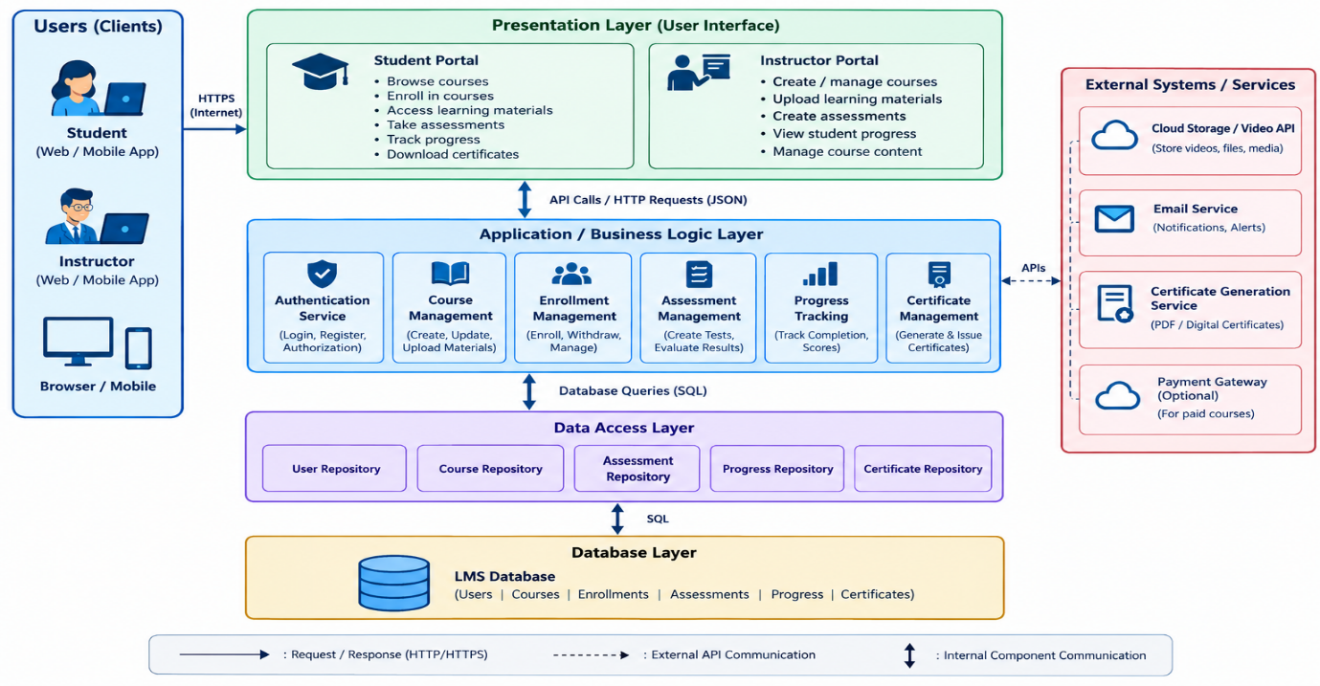

The assignment specifically requires the architecture diagram to show major components, databases, external systems, APIs, communication mechanisms, and appropriate labels.

4. Explain Components and Their Interactions

4.1 Presentation Layer
The Presentation Layer provides the user interface for students and instructors.
Student functions:
- Register/login
- Browse courses
- Enroll in courses
- Access learning materials
- Attend assessments
- View progress
- Download certificates
Instructor functions:
- Login
- Create courses
- Upload materials
- Create assessments
- View student progress
- Manage course content

4.2 Authentication Service
This component manages user registration, login, logout, authentication, and authorization. It ensures that students and instructors can access only the features allowed for their roles.

4.3 Course Management
This component allows instructors to:
- Create courses
- Update course information
- Upload learning materials
- Delete or modify course content
Students use this component to view available courses and course information.

4.4 Enrollment Management
This component manages student enrollment.
Flow:
Student → Select Course → Enrollment Request
→ Enrollment Management
→ Database
→ Enrollment Confirmation

4.5 Assessment Management
This component manages quizzes, tests, questions, answers, marks, and assessment results.
Students submit their answers, and the system stores and processes the results.

4.6 Progress Tracking
This component records:
- Lessons completed
- Learning materials accessed
- Assessment completion
- Assessment scores
- Overall course completion percentage

4.7 Certificate Management
When a student completes the required course activities and assessments, the Certificate Management component generates a certificate and stores its details.

4.8 Database
The database stores:
- User information
- Course details
- Learning materials
- Enrollment details
- Assessment questions
- Assessment results
- Student progress
- Certificate information

Overall Workflow
User Registration/Login
↓
Browse Course
↓
Enroll in Course
↓
Access Learning Materials
↓
Attend Assessments
↓
Track Progress
↓
Course Completion Check
↓
Certificate Generation
The assignment requires both component responsibilities and their communication/data exchange to be explained.

5. Discuss Quality Attributes

5.1 Scalability
The layered architecture allows individual components to be improved or scaled as the number of students and courses increases. Additional application servers can be added when user traffic becomes high.

5.2 Security
Security is maintained through:
- User authentication
- Role-based authorization
- Secure password storage
- HTTPS communication
- Access control for course and assessment data

5.3 Performance
The application layer processes requests efficiently, while the Data Access Layer manages database operations. Database indexing and caching can be used to improve response time.

5.4 Reliability
Important information such as assessment results, enrollment records, and student progress is stored in the database. Regular database backup can reduce the risk of data loss.

5.5 Maintainability
Each layer has a separate responsibility. Therefore, changes in one layer can be made with minimal effect on other layers.
For example, the user interface can be redesigned without changing the database structure.

5.6 Availability
The system can be hosted on reliable cloud infrastructure with backup and recovery mechanisms. This allows students and instructors to access the platform with minimum downtime.
These six quality attributes directly match the evaluation areas specified in the assignment.

6. Justify Architectural Decisions

6.1 Rationale
Layered Architecture is selected because the LMS has clearly defined responsibilities. Separating presentation, business logic, data access, and database operations improves system organization and maintainability.
The Client-Server model allows students and instructors to access the platform through web or mobile clients while the server manages business operations and data.

6.2 Trade-Offs
Advantages:
- Simple and well-organized structure
- Easy maintenance
- Easy testing
- Better separation of responsibilities
- Supports future expansion
- Easier database management
Trade-offs:
- Communication between multiple layers can introduce some processing overhead.
- For a very large system, additional services may be required to handle extremely high traffic.
- Proper database and server management is required as the number of users increases.

6.3 Future Enhancements
The architecture can support future features such as:
- Live online classes
- AI-based personalized course recommendations
- Discussion forums
- Online payment integration
- Mobile application
- Email and notification services
- Advanced learning analytics
- Cloud-based video storage
- AI-based assessment analysis
The selected architecture therefore provides a structured foundation for future system integration and long-term maintainability, which aligns with the assignment's requirement to discuss future enhancements and integration.

Conclusion
The proposed Layered Client-Server Architecture is suitable for the Online Course Learning Management System because it separates the user interface, business logic, data access, and database responsibilities. It provides good scalability, security, performance, reliability, maintainability, and availability. The architecture can also be extended with cloud services, mobile applications, AI-based recommendations, and other future learning technologies.

